Press release
____________

Tarkett North America

Tarkett Introduces NuGen™ for Hospitality
Rigid Core Flooring that is Flexible, Beautiful and Easy to Install
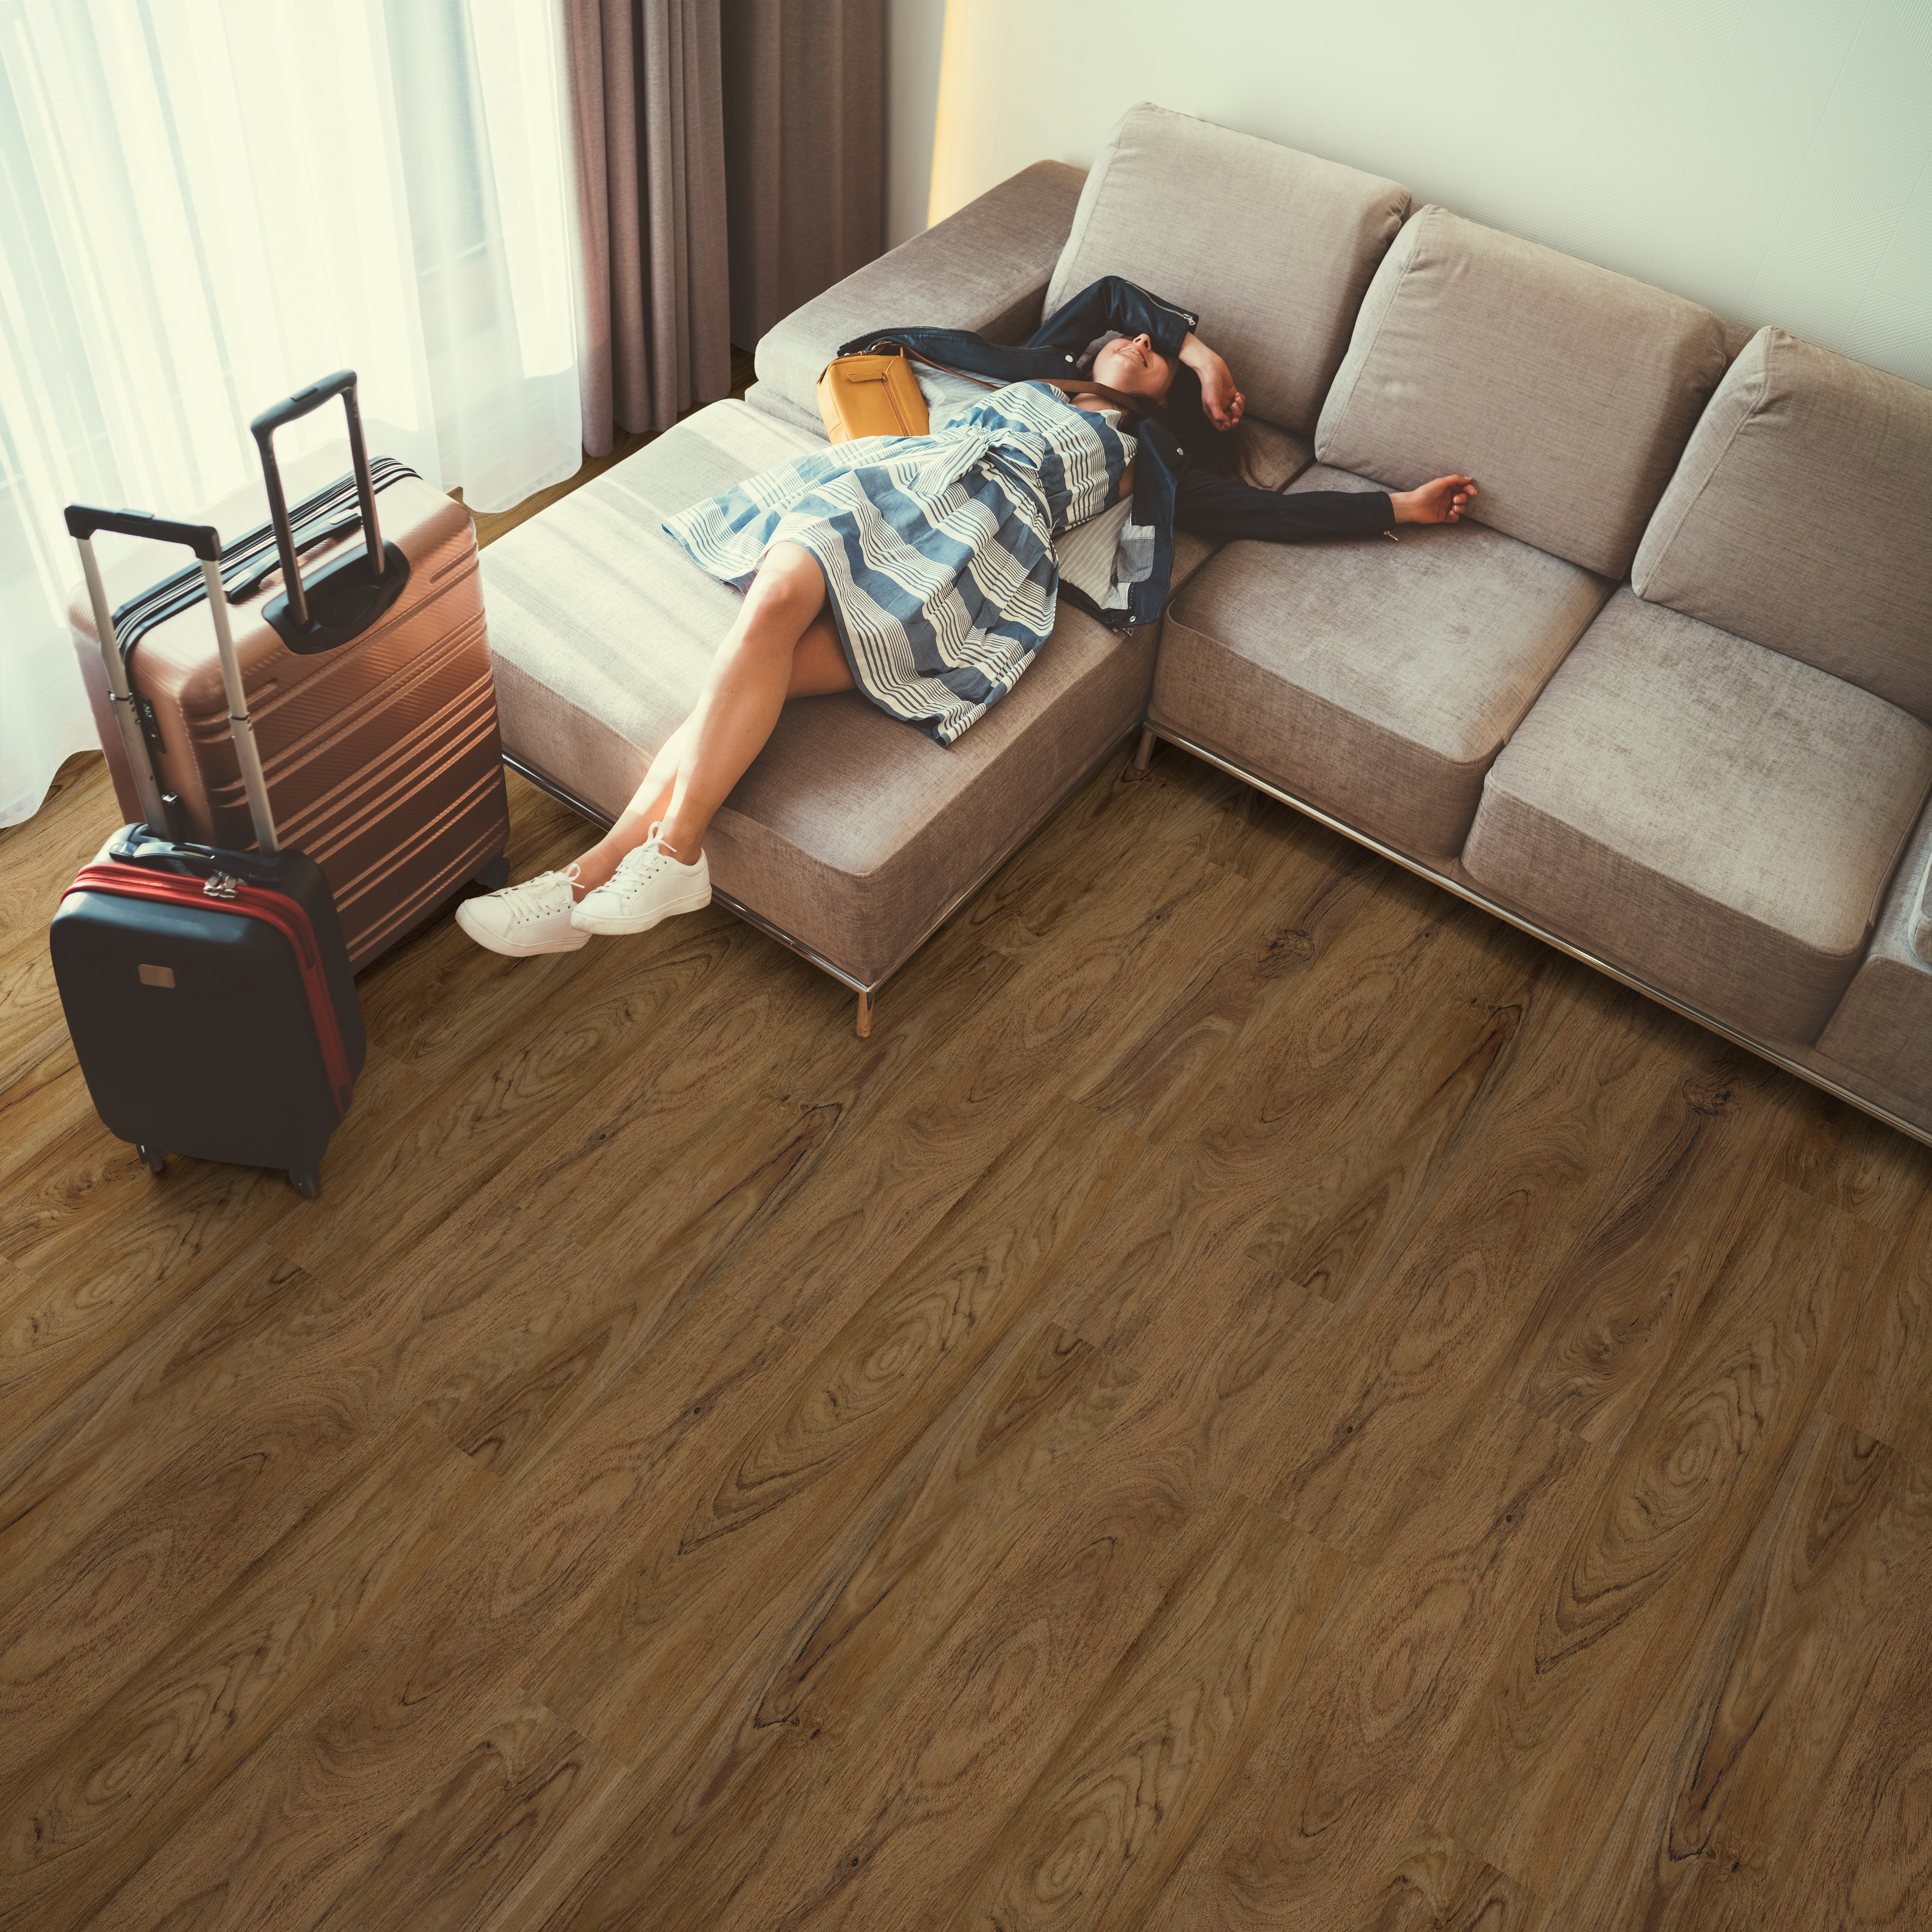

SOLON, OHIO, NOVEMBER 26, 2019 — Tarkett, a worldwide leader in innovative and sustainable flooring and sports surface solutions, announces the launch of NuGen™ luxury vinyl flooring that offers the best of both worlds: the enhanced performance of rigid core strength, with a suite of flexible designs for today’s most frequented hotels.
Tarkett designed NuGen in response to the hospitality industry’s need for a rigid core flooring with more flexibility, easy installation, and beautiful design. Available only in our bestselling colors and patterns, each style delivers the authentic look of natural wood grain, so there’s never a wrong selection. Perfect for guest rooms, weight free fitness rooms, and employee break areas, NuGen delivers beauty, value and waterproof performance to meet the demands of today’s hospitality environments.
“NuGen was designed to answer everything our customers have requested in a holistic flooring solution. When we’re talking to hospitality professionals, the overwhelming need is a floorcovering that’s flexible enough to provide beauty, comfort and performance in every room. From easy installation and maintenance to guaranteed long-term wear, NuGen is an ideal choice for the building or renovation project and the property,” said Sam Burger, vice president of hospitality sales for Tarkett North America.
NuGen is 100% post-consumer recyclable right back into new LVT products and is FloorScore® certified and phthalate-free.
More information about all of Tarkett’s products can be found at www.tarkettna.com. High-resolution product images available upon request.
###
About Tarkett
With a history stretching back 135 years, Tarkett is a worldwide leader in innovative flooring and sports surface solutions, with net sales of more than €2.8 billion in 2018. Offering a wide range of products, including vinyl, linoleum, rubber, carpet, wood, laminate, artificial turf and athletic tracks, the Group serves customers in over 100 countries across the globe. Tarkett has 13,000 employees and 36 industrial sites and sells 1.3 million square meters of flooring every day, for hospitals, schools, housing, hotels, offices, stores and sports fields. Committed to "Doing Good—Together," the Group has implemented an eco-innovation strategy that is based on Cradle to Cradle principles and promotes a circular economy, with the ultimate goal of contributing to people's health and wellbeing, and preserving natural capital. Tarkett is listed on Euronext Paris (compartment A, ISIN: FR0004188670, ticker: TKTT) and is included in the following indices: SBF 120 and CAC Mid 60 www.tarkett.com.

Tarkett North America Media Contact

Christie Boyle
Chrysanthemum Partners

646-342-2571
cb@chrysanthemumpartners.com

